**Abhinav Jain**

**500083840**

**EXPERIMENT-6**

Title: 6. To understand the concepts of Views.

Objective: Students will be able to implement the concept of views.

1. **Create table of table name: EMPLOYEES and add 6 rows**

Create table EMPLOYEES (Employee_id varchar(10) primary key,

First_name varchar(30) Not Null,

Last_Name varchar(30) Not Null,

DOB varchar(20),

Salary integer Not null,

Department_id varchar(10));

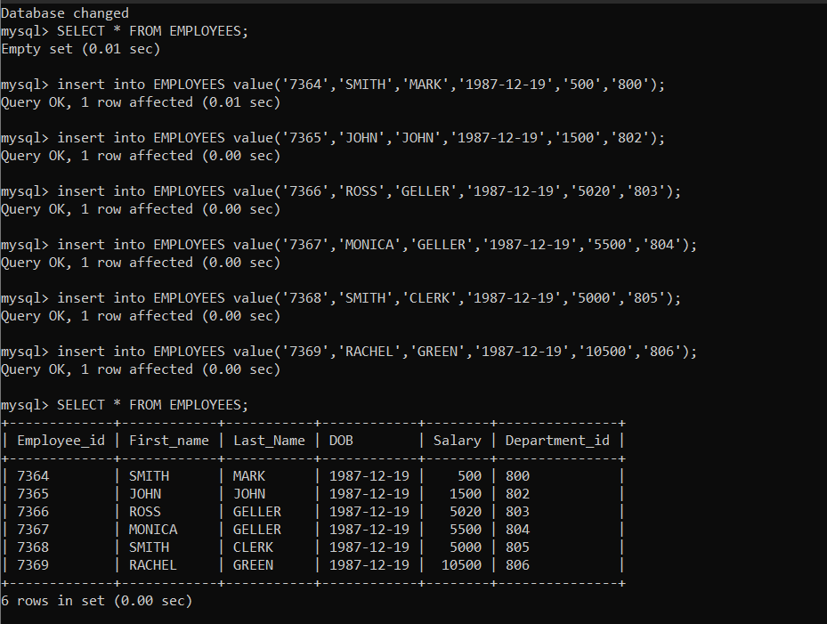

**2. Execute the following view related queries:**

1) Create View of name emp_view and the column would be Employee_id, Last_Name, salary and department_id only.

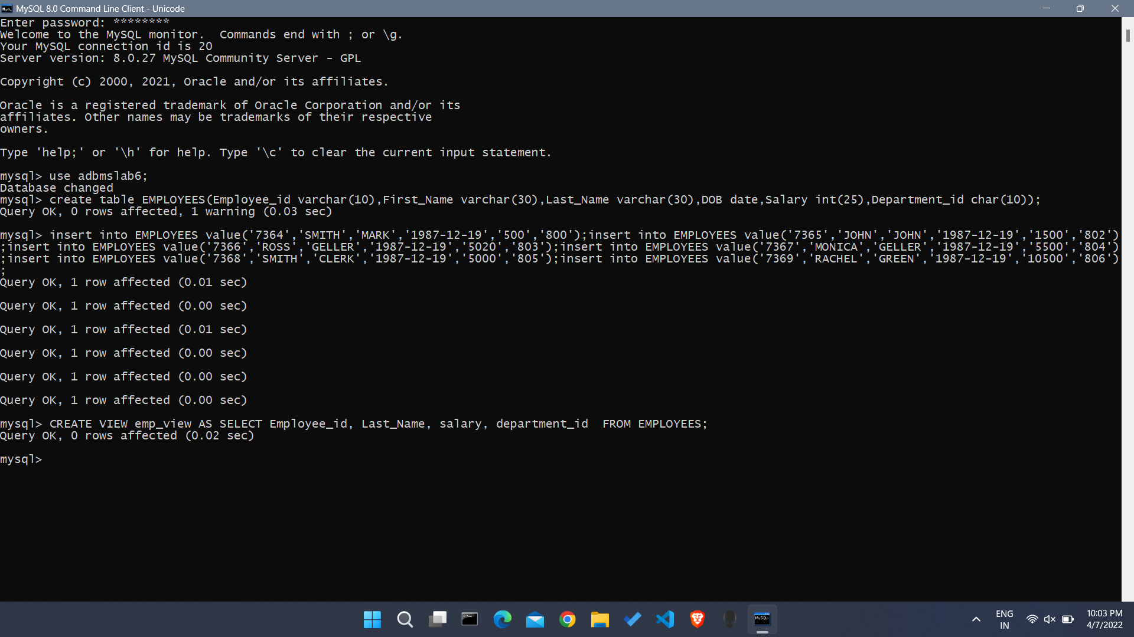

2) Insert values into view(remove the NOT NULL constraint and then insert values):

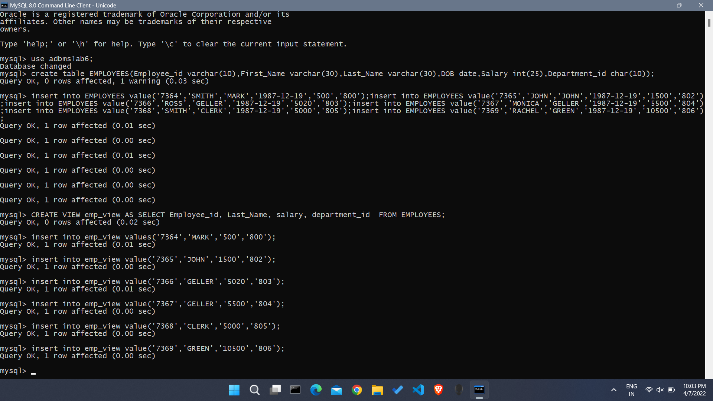

3) Modify, delete and drop operations are performed on view.

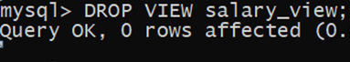

4) Creates a view named salary_view. The view shows the employees in department 20 and their annual salary.

